**Core Java Assignment 8**

**Lambda**

**1.**

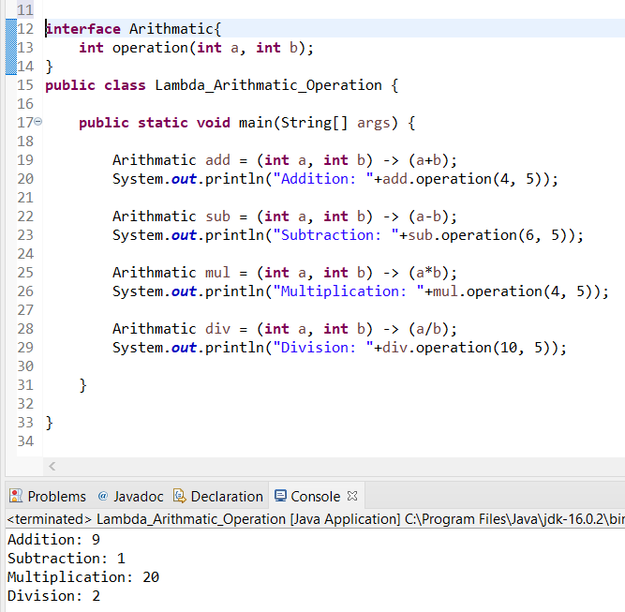

**2.**

**import** java.util.ArrayList;

**import** java.util.List;

**import** java.util.stream.Stream;

**class** Order{

String item;

**int** price;

String status;

**public** Order(String item, **int** price, String status) {

**super**();

**this**.item = item;

**this**.price = price;

**this**.status = status;

}

**public** String getItem() {

**return** item;

}

**public** **void** setItem(String item) {

**this**.item = item;

}

**public** **int** getPrice() {

**return** price;

}

**public** **void** setPrice(**int** price) {

**this**.price = price;

}

**public** String getStatus() {

**return** status;

}

**public** **void** setStatus(String status) {

**this**.status = status;

}

@Override

**public** String toString() {

**return** "Order [item=" + item + ", price=" + price + ", status=" + status + "]";

}

}

**public** **class** Order_Q2_A8 {

**public** **static** **void** main(String[] args) {

List<Order> l =**new** ArrayList<>();

l.add(**new** Order("Jeans",11000,"ACCEPTED"));

l.add(**new** Order("Shirts",5000,"COMPLETED"));

l.add(**new** Order("Tops",22000,"COMPLETED"));

l.add(**new** Order("Kurti",8000,"ACCEPTED"));

System.***out***.println("Orders having price greater than 10000");

Stream<Order> filtered_data = l.stream().filter(p -> p.price > 10000);

filtered_data.forEach(

o->System.***out***.println(o.item+" "+o.price+" "+o.status)

);

System.***out***.println("\nOrders having status ACCEPTED");

l.stream().filter(p->p.getStatus().matches("ACCEPTED")).forEach(

o->System.***out***.println(o.item+" "+o.price+" "+o.status)

);

System.***out***.println("\nOrders having status COMPLETED");

l.stream().filter(p->p.getStatus().matches("COMPLETED")).forEach(

o->System.***out***.println(o.item+" "+o.price+" "+o.status)

);

}

}

**Output:**

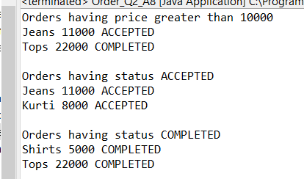

**3.**

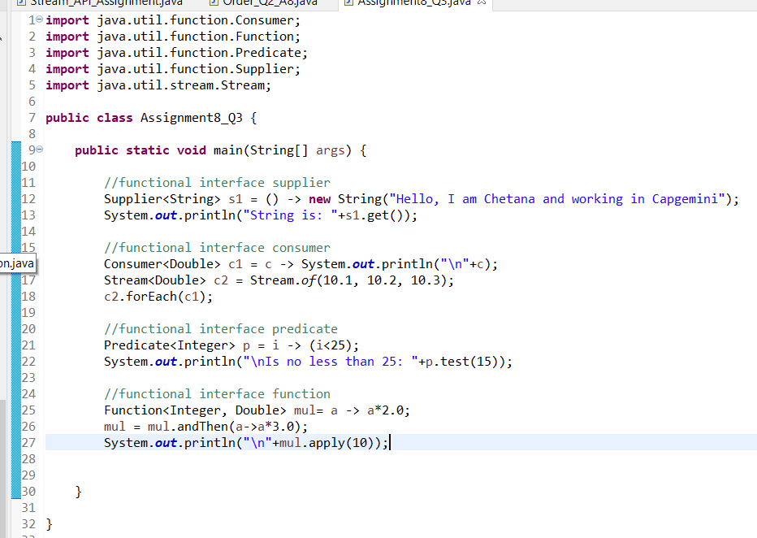

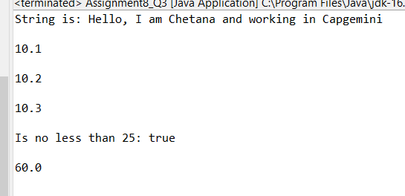

**4.**

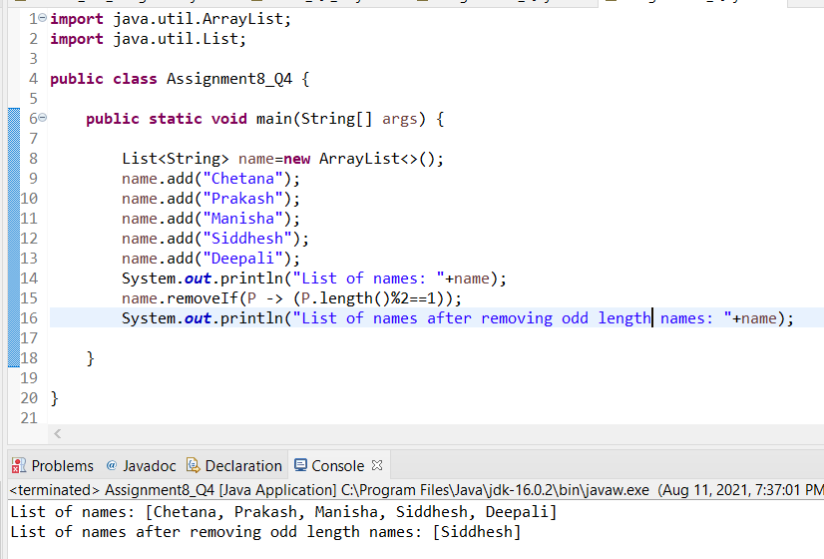

**5.**

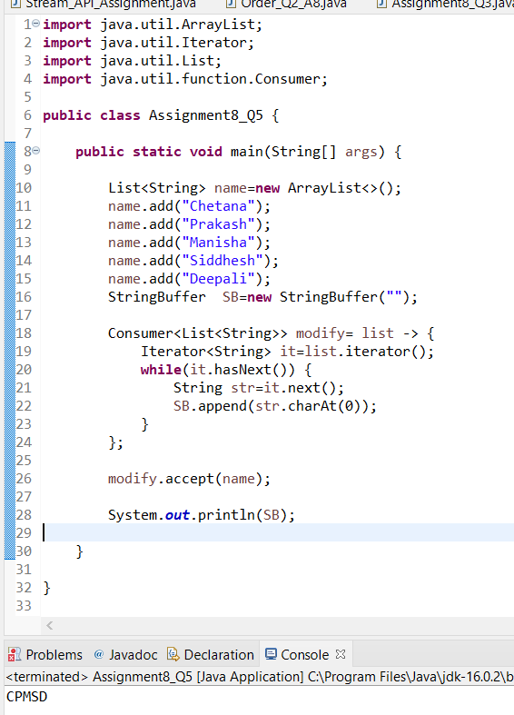

**6.**

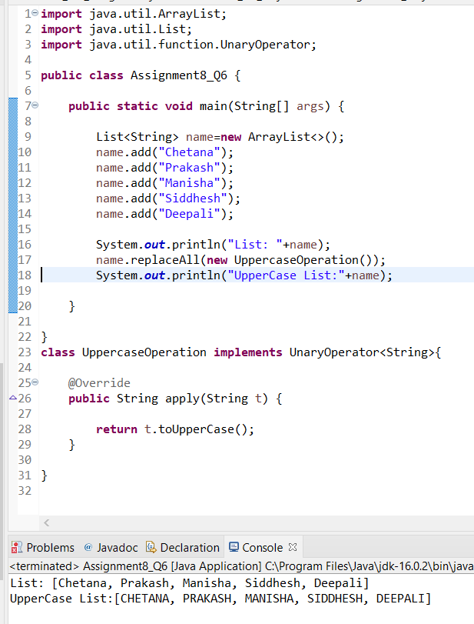

**7.**

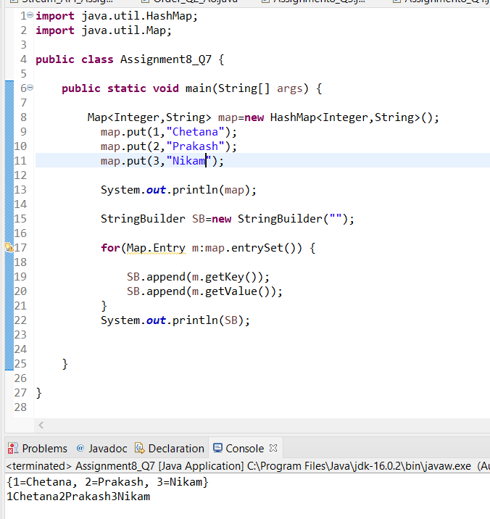

**8.**

